**Fitness Tracking and Training System**

**PROPOSAL 2 (MILESTONE 2)**

**Members**

|  |  |  |
| --- | --- | --- |
| **Stt** | **Họ và tên** | **Student ID** |
| **1** | Lê Minh Phượng | ITITIU20281 |
| **2** | Nguyễn Minh Đức | ITITIU21045 |
| **3** | Phạm Quang Vinh | ITITIU21347 |
| **4** | Đỗ Đức Huy | ITITIU21217 |
| **5** | Bùi Đức Mạnh | ITITIU21076 |
| **6** | Hồ Tiến Đạt | ITCSIU21047 |
| **7** | Nguyễn Huy Hùng | ITCSIU21064 |
| **8** | Nguyễn Toàn Phúc | ITITIU21093 |
| **9** | Vũ Đức Thiên Hoàng | ITITWE20028 |
| **10** |  |  |

1. **Introduction**
2. **Overview:**In this proposal, we will cover various aspects that are crucial to the success of our project. We will start by identifying the key stakeholders who will be involved in the development and usage of the app. Next, we will dive into the user requirements, ensuring that we understand the needs and expectations of our target audience. Additionally, we will outline the functional requirements that the app should fulfill in order to provide a seamless user experience. To visualize the app's structure, we will provide wireframes, an ERD, an activity diagram, and a class diagram. Furthermore, we will conduct a thorough requirement analysis to ensure that all necessary features and functionalities are included. Lastly, we will perform a risk analysis to identify potential challenges and develop strategies to mitigate them.
3. **Scope:**Fitness Tracking App with Personalized Workouts, Diets, and Daily Reminders
   * + **Workout tracking:** Track workouts by type, duration, and intensity.
     + **Nutrition tracking:** Track food and drink intake to track calories, macronutrients, and micronutrients.
     + **Fitness goal setting:** Set and track fitness goals, such as weight loss, muscle gain, or improved cardiovascular health.
     + **Personalized workouts:** Generate personalized workouts based on the user's fitness level and goals.
     + **Diet plans:** Generate personalized diet plans based on the user's weight, height, and fitness goals.
4. **Objectives:**
   * + Help users lose weight or gain muscle.
     + Improve users' cardiovascular health.
     + Increase users' strength and flexibility.
     + Reduce users' risk of chronic diseases.
     + Help users develop healthy lifestyle habits
     + Develop a personalized workout plan tailored to their fitness level and goals.
     + Create a healthy diet plan that meets their individual needs.
     + Stay motivated and on track with their fitness journey by receiving daily reminders.
5. **Implementation details:**
   1. **Diagram Drawing:**

* draw.io: A web-based diagramming tool that allows you to create various types of diagrams, such as flowcharts, UML diagrams, and network diagrams.
* Lucidchart: An online diagramming and visual communication tool that offers a wide range of diagram templates and collaboration features.
  1. **Co-op Writing:**

Google Docs: A cloud-based word processing software that enables multiple users to collaborate on a document simultaneously. It provides real-time editing, commenting, and version history.

* 1. **Integrated Development Environment (IDE):**

PHPStorm: A powerful IDE specifically designed for PHP development. It offers features like code completion, debugging, version control integration, and database tools for working with Apache and SQL.

* 1. **Programming Language:**

Java: A widely-used object-oriented programming language known for its platform independence and versatility. It is commonly used for developing Android applications.

* 1. **Web Development Tools:**

XAMPP: A free and open-source cross-platform web server solution that includes Apache, MySQL, PHP, and Perl. It allows you to set up a local development environment for creating and testing databases with SQL and running PHP scripts.

* 1. **Mobile Development:**

Android Studio: The official Integrated Development Environment (IDE) for Android app development. It provides a comprehensive set of tools for designing, coding, debugging, and testing Android applications. Android Studio supports Java as the primary programming language.

* 1. **Software Engineering Principle:**

Agile Development: An iterative and incremental approach to software development that emphasizes flexibility, collaboration, and customer satisfaction. It involves breaking down the project into manageable tasks and working on them in sprints.

**II. Key stakeholders and user requirements**

1. **Key stakeholders**
   * + Customers
     + Personal Trainer
     + Software Admin
2. **Requirements (initial)**
   * + Customer: Constantly upload their personal and health information on the software. Always track and receive customized nutrition, workout plans, notification, etc from the system. Can monitor and witness their workout journey and results from the initial days to the present. From that, the users get motivated and continue their workout process.
     + Personal trainer: is the main stakeholder who directly interacts with and influences the routine, workout plans, and nutrition,.. of the users. They are the ones who set up and list out all the necessities that support the workout process of the users. They are also the ones who have knowledge and expertise that will always give advice, answer questions, and support in the health and fitness criteria.
     + Software admin: the main stakeholder that controls the input and output information of the users. Responsible for exporting and conveying the information, plans, and nutrition from the Personal Trainer to the Users. They also set up and manage the time and notifications that will be sent to Users. Moreover, share contact, help, and support at any time if required. Play a huge role in linking and connecting users directly with Personal Trainers.

**III. Functional requirements**

1. **BPMN**
2. **Register account**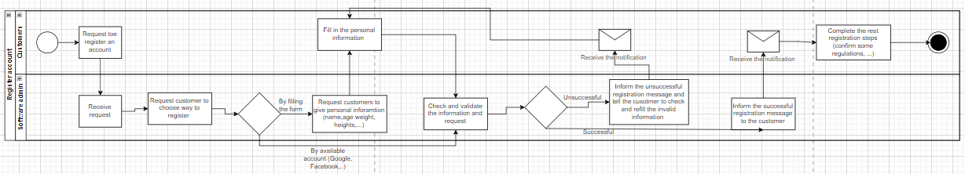

Customers request to register an account by clicking on the “Register” button, then the admin receives the request and tells the customers to choose the way - filling out the form or using an available account. If they choose the form, the admin will ask for their personal information (name, age, weight, height,...) and the customers will fill out the form on the screen. After that, the admin checks and validates the information and request. If they choose to register by an available account such as Google or Facebook, they have to click on the icon of the software, then the admin will check and validate the information and request immediately. When it’s successful, the admin will inform the successful registration message to the customers, they will receive the notification and complete the rest of the registration steps (confirm some regulations,...). Otherwise, the customers will receive the notification about validating errors and register again.

1. **Get workout information**

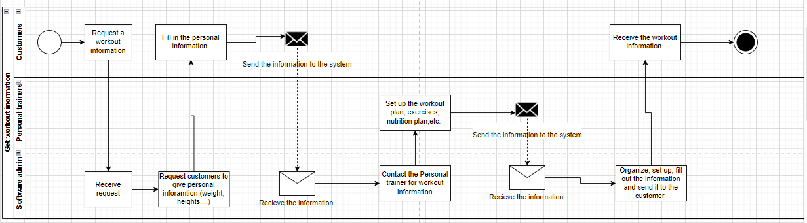

Customers request workout information, then the software admin receives the request and asks the customers about personal information (weight, height,...). The customers will fill in the needed information and send it to the system; after receiving the information, the software admin contacts the personal trainers (PT) for workout information. The PT will set up the workout plan, exercises, nutrition plan, etc. based on the customers’ information. When finished, the PT sends the workout information to the system; the software admin after receiving the information will organize, set up, fill out the information and send it to the customers. Finally, they receive the needed workout information.

**c) Get help and advice**

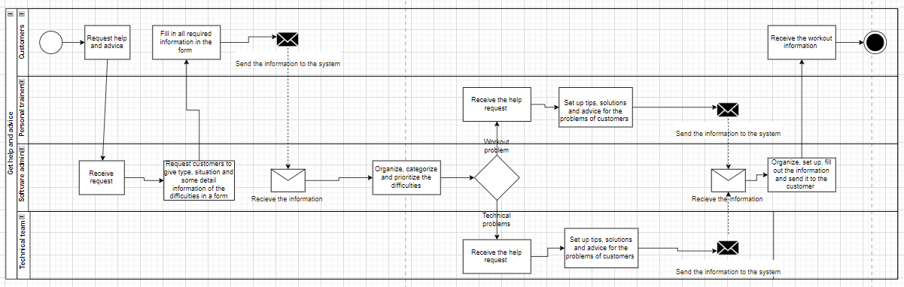

Customers request help and advice, and the admin after receiving the request will ask the customers to give type, situation, and some detailed information about the difficulties in a form. The customers fill in all required information in the form and send it to the system, by the time the software admin receives it, he will organize, categorize and prioritize the difficulties. There are two types of problems: Workout and Technical; Workout problems will be handled by PT while the Technical team is responsible for Technical problems. Both teams have the same process in dealing with those problems, after receiving the help request, they will set up tips, solutions and advice for the problems of customers. Then send that information to the system, software admin will be the receiver and then organize, set up, fill out the information and send it to the customers. Finally, the customers get the required advice.

**d) Monitoring and tracking the workout process**

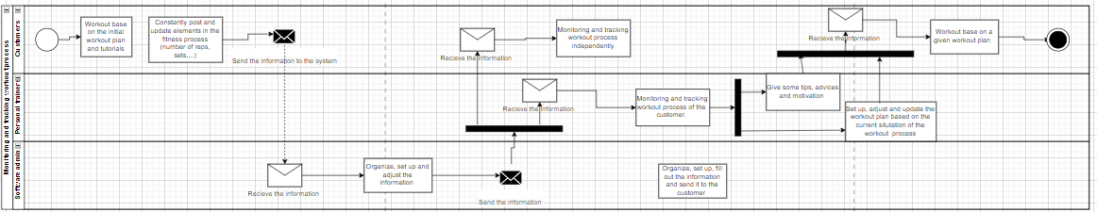

Customers exercise the initial workout plan and tutorials, after that, they constantly post and update elements in the fitness process (number of reps, sets,...). That information will be sent to the system where the software admin receives, organizes, sets up and adjusts the information, it will be sent to PT or customers. Customers can monitor and track workout processes independently while PT will do the same for the customers. PT can give some tips, advice and motivation or set up, adjust and update the workout plan based on the current situation of the workout process, then PT will send it to the customer. The customers receive and follow the workout exercises based on the given plan.

**2) Usecase**

# **Characteristic Information**

The following defines information that pertains to this particular use case. Each piece of information is important in understanding the purpose behind the Use Case.

|  |  |
| --- | --- |
| **Goal In Context:** | The school will be able to analyze the student's academic performance rating in a semester. |
| **Scope:** | * **Workout tracking:** Track workouts by type, duration, and intensity. * **Nutrition tracking:** Track food and drink intake to track calories, macronutrients, and micronutrients. * **Fitness goal setting:** Set and track fitness goals, such as weight loss, muscle gain, or improved cardiovascular health. * **Personalized workouts:** Generate personalized workouts based on the user's fitness level and goals. * **Diet plans:** Generate personalized diet plans based on the user's body weight, height, and fitness goals. |
| **Level:** | Strategic |
| **Precondition:** | Users will sign up for the fitness training gym |
| **Success End Condition:** | Users who register for fitness services will be provided with app fitness services |
| **Failed End Condition:** | Users didn’t register for the fitness services |
| **Primary Actor:** | PT: provide the work out guide road  Admin: update and management the app  User: use the work out guide road |
| **Trigger Event:** | Normally after the users register for the services |

# **b) Main Success Scenario**

This Scenario describes the steps that are taken from trigger event to goal completion when everything works without failure. It also describes any required cleanup that is done after the goal has been reached. The steps are listed below:

|  |  |  |
| --- | --- | --- |
| **Step** | **Actor** | **Action Description** |
| Step 1 | PT | Create their profile |
| Step 2 | Admin | Update and save the PT’s profile information |
| Step 3 | User | Create their profile |
| Step 4 | Admin | Update and save the User’s profile information |
| Step 5 | PT | Create workout sets and send to the app |
| Step 6 | Admin | Update and save workout sets from PT |
| Step 7 | PT | Make a nutrition plan and send to the |
| Step 8 | PT | Make view the nutrition, which includes Meals Recommendation |
| Step 9 | Admin | Update and save the nutrition plan from the PT |
| Step 10 | Admin | Send the workout progress and nutrition plan to the User |
| Step 11 | User | Star session, which includes:   * Begin session: Choose Duration, muscle, difficulty * End session: Take check-in pic |
| Step 12 | User, Admin | View the progress and nutrition plan |
| Step 13 | PT | Return step 5 |

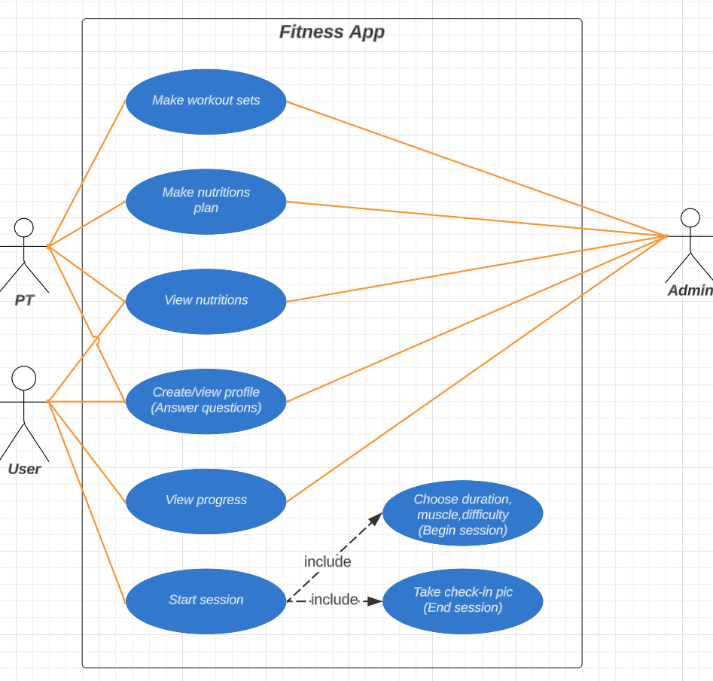

Use Case Diagram

**c)** **Details**

**c1. Make workout sets**

Usecase Make-workout-sets:

_Actor: Pt, customer, and Admin

_Pre-Condition:

+PT must have the profile on the apps

_Post-Condition: PT workout sets are in the app systems

_The basic flow of event:

+The PT design customized workout programs on varieties duration, muscle, difficulty

+Admin will upload the workout sets to the database

+After PT receive the latest check-in of the customer after a month, the PT design new customized workout programs based on the latest states

+The process will repeat until the customer end their services

**c2. Make nutrition plan**

Use Case Make-nutrition-plan:

_Actor: Pt and Admin

_Pre-Condition:

+PT must have a profile on the apps

_Post-Condition: PT nutrition is in the app systems

_The basic flow of event:

The PT designs a customized menu that suits the customer needs

Admin will upload the workout sets to the database

After PT receive the latest check-in of the customer after a month in the view nutrition, the PT design new customized menu based on the latest states

The process will repeat until the customer end their services

**c3. View nutrition**

Use Case Nutrition-view:

_Actor: Pt, customer

_Pre-Condition:

+After the customer starts their customized meal in 1 week

_Post-Condition: PT and customer can track the nutrient levels

_The basic flow of event:

+ After a week, the user will fill in their new health states

+The states will be uploaded to the database and shown into the nutrition tracking page

+The PT will be allowed to see the result from their customer

**c4. Create/view profile**

Usecase create-view-profile:

_Actor: Pt, Customer, Admin

_Pre-Condition:

+PT take the job in the gym

+Customer take the service

_Post-Condition: PT and Customers information are in the app systems

_The basic flow of event:

+At the register menu, there is a question ask that whether they are PT or Customer:

+PT and Customers fill in their personal information

+Admin check the information:

*If the information pass, Admin upload the information to the database

*If the information is false, Admin ask the PT and Customer to refill the incorrect or missing information

+After uploading, admin show the information in the personal information page

**c5. View progress**

Usecase create-view-profile:

_Actor: Pt, Customer

_Pre-Condition:

+After the customer starts their sets in 1 week

_Post-Condition: PT and Customers can track the progress from the customer

_The basic flow of event:

+After a week, the PT will conclude the workout process

+The states will be uploaded to the database and shown into the working tracking page

+The customer will be allowed to see the result from their training

**c6. Start session**

Use Case Start session:

_Actor: Pt, Customer

_Pre-Condition:

+After the customer start their sets in 1 week

_Post-Condition: Customers can take the session that suits for them

_The basic flow of event:

+ Customer start to choose their duration, muscle, and difficulty

+Customer start training based on the session that was given based on their choices

+After finish the session, The customer is asked to take check-in picture to confirm their session

+The check-in picture will be uploaded to the database and sent to the PT

**IV.Wireframe**

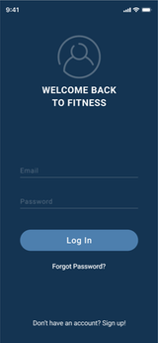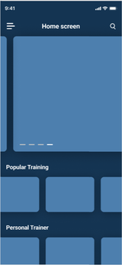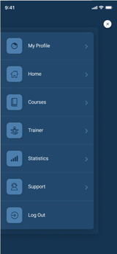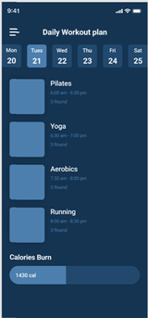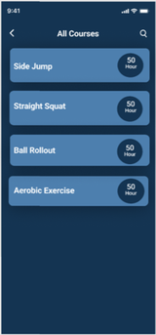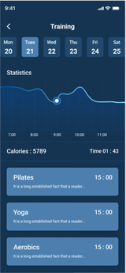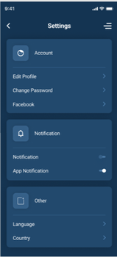

**V. ERD**

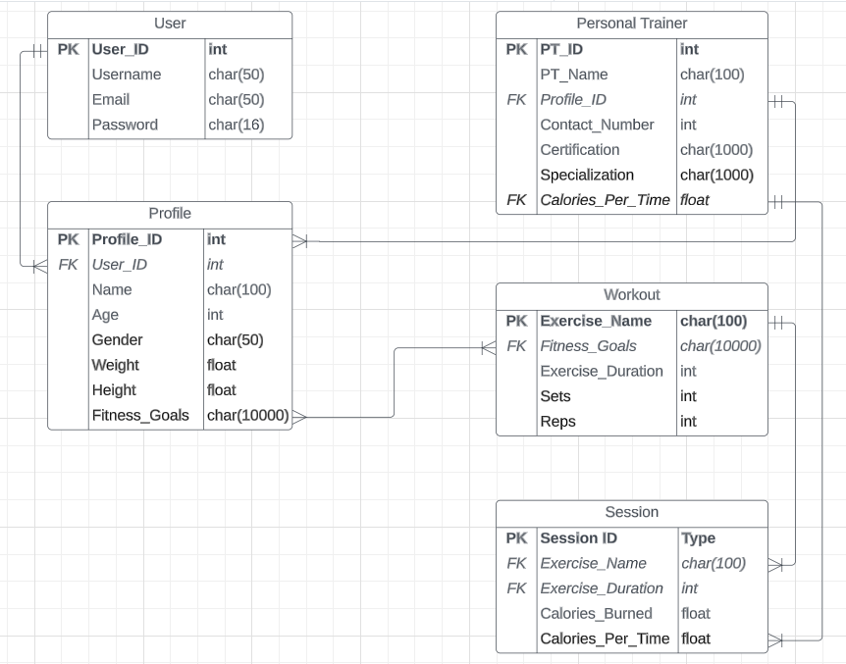

**VI. Activity diagram**

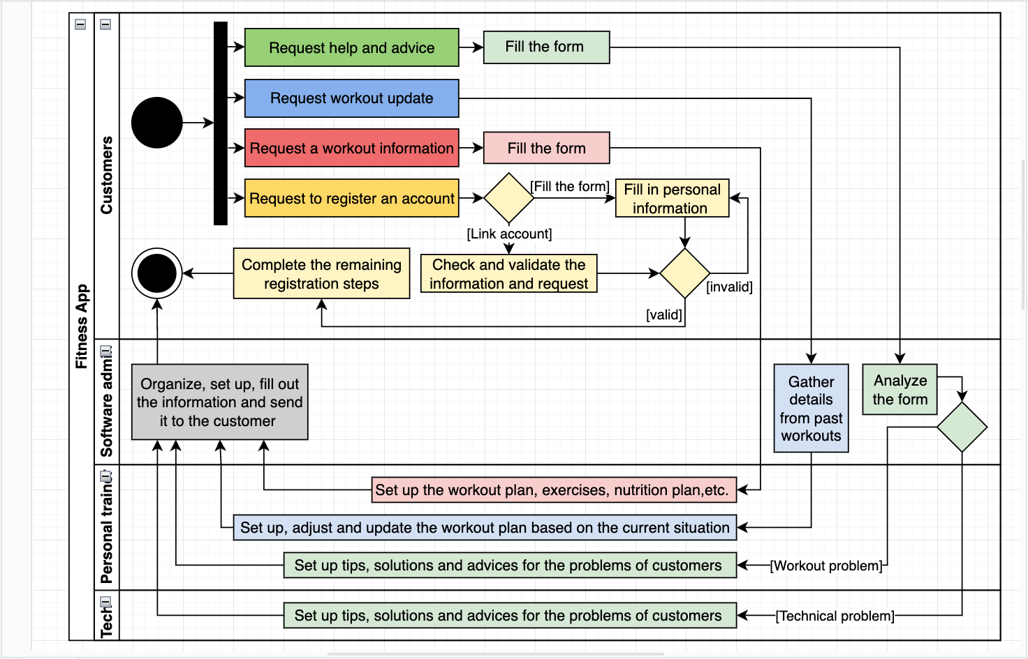

**VII. Class Diagram**

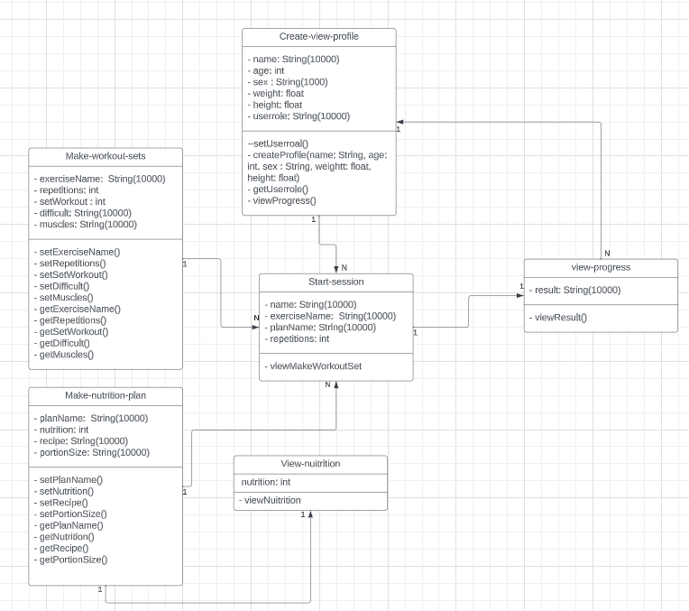

**VIII. Sequence Diagram**

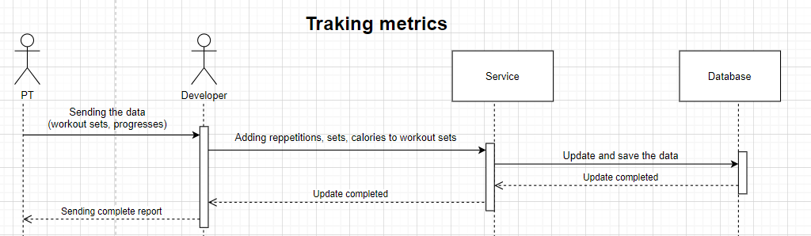

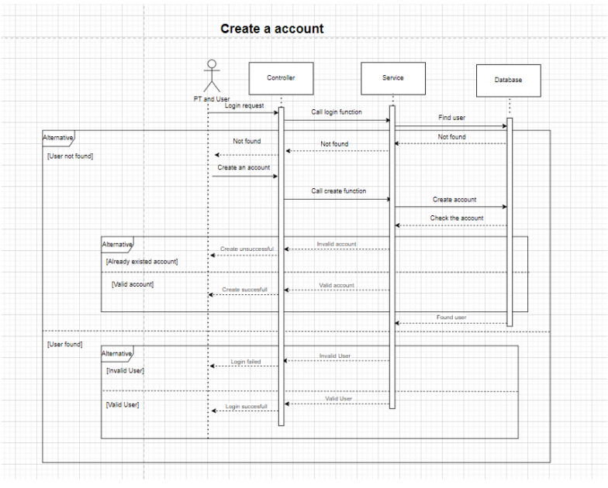

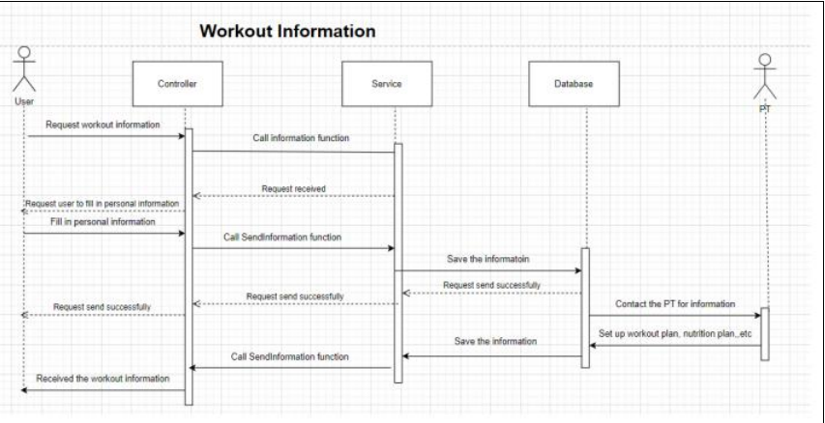

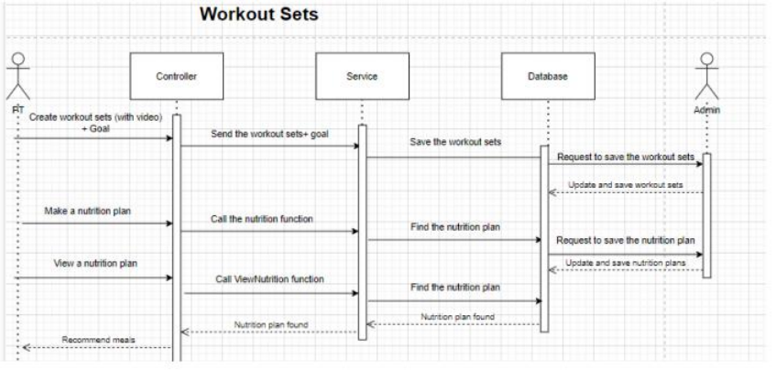

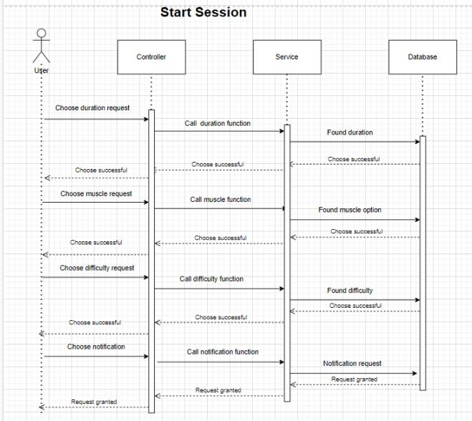

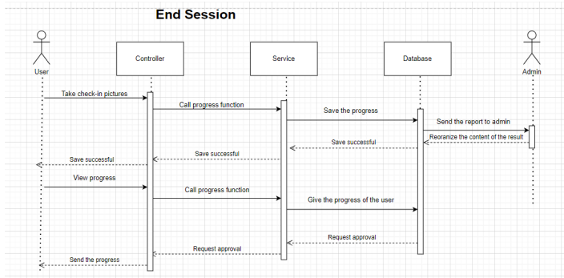

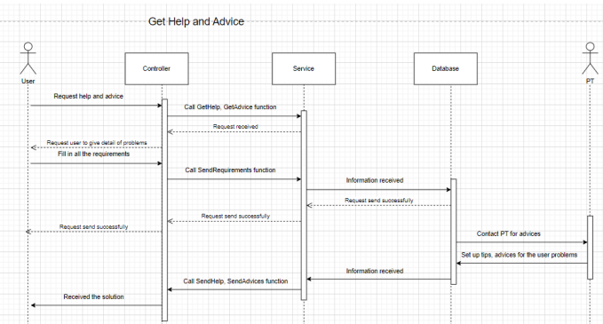

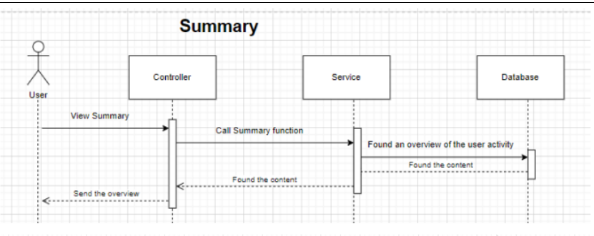

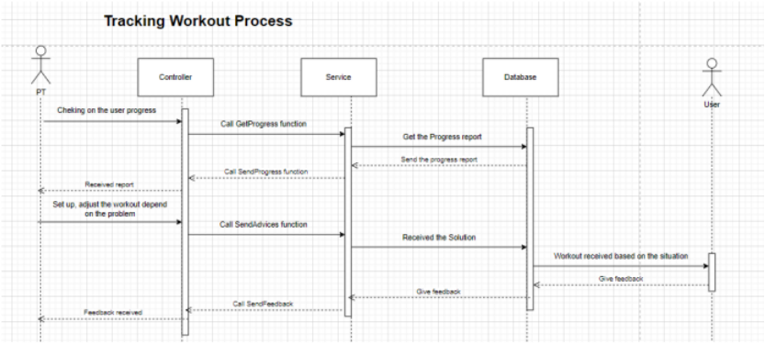

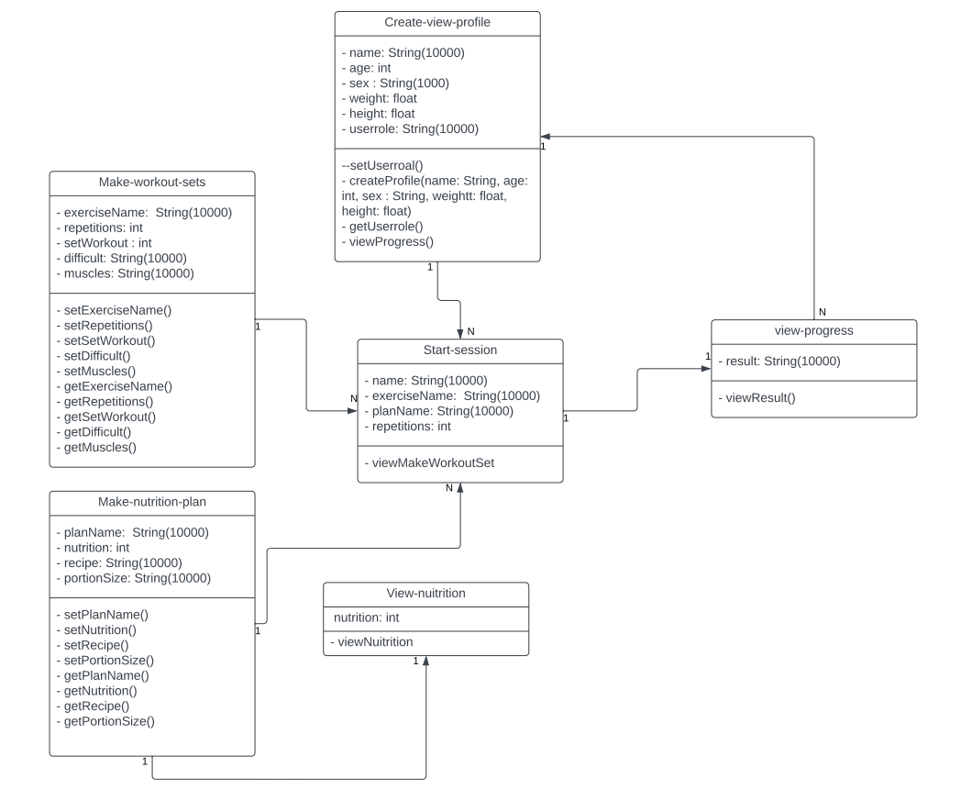

**IX. Requirement Analysis**

**Note:** The table has already been filtered out to each category and in order of priority ( most important at the top to least important at the bottom)

|  |  |  |  |
| --- | --- | --- | --- |
| **Requirement name** | **Description** | **Category** | **Note** |
| Running platform and environment | App is best suit for user, but web is good for admin to manage | Non- functional |  |
| Required information for tracking and monitoring exercise routine | Day, Time, Food history, Exercise history, Weight,... other metrics about fitness | Non- functional |  |
| Motivation for user and customer(1) | Products must ensure quality, reasonable prices, and ease of use.  Service: Customer care must be good to encourage customers to return, providing conveniences such as easy online shopping, fast delivery, and quick return policies. | Non - functional |  |
| Motivation for user and customer(2) | Feedback: Asking for customer reviews and listening to their opinions shows that they are important, leading to a sense of participation and motivation to contribute to the brand's development.  Innovation: Introducing new features, products, or services based on customer feedback and market trends can create user excitement and motivation.  Promotion program: Discounts for loyal customers. | Non-functional |  |
| Types of private information that the software will store | Personal details, and health information (name, age, address, weight, etc.) | Non-functional | May contain multiple layers of security |
| Number of clicks customers want to make to reach each function interface | Depends on the design (Around 2 - 4 clicks is good number) | Non-functional |  |
| Design | Catchy, friendly, easy-to-use interface | Non-functional | Use color and design that suitable for different of ages |
| Time for system's maintenance | Depends on the complexity of your system. Usually once every 6 months | Non-functional |  |
| Maximum number of customers that the system can contemporarily store | Depends on the size of user that system can reach | Non-functional | The system now only contains below 100 users |
| Time the service needs to be available for the customer | 24/7, if all the function can be done automatically without human (in our case is PT and admin) | Non-functional |  |
| Conditions to categorize reviews from users | Write scenarios (operating scripts), if the user completes those scenarios without encountering any difficulties, tick completed. If not, see where the user is having difficulty. Example: The user wants to update their eating history, they need to enter the date, mealtime, and the food they ate --> the system will save and update if there are any changes, however, the user can only enter one food, it should be able to enter more --> that scenario is not successful in fulfilling the user's task. | Functional |  |
| Functions or criteria to build an appropriate set of goals | Goal of the user: Customers want to track their health, and follow their process flow of daily exercises. | Functional |  |
| Set securities for the private information | Data encryption, secure authentication. Items like password | Functional |  |
| Circumstances to reach help for customers | Text, call or email. Simply put the contact in the website without coding a function just to support | Functional |  |
| Handle with good/ bad comments and feedback from customers | Point out any improvement that the team can do with those feedbacks | Transition | Using Google Form is suggested |
| Sports and fitness rules need to be covered | Need more research | Transition | Currently need to cover Vietnamese rule and regulation only |

**XIX. Risk analysis**

|  |  |  |  |  |  |
| --- | --- | --- | --- | --- | --- |
| **Risk ID** | **Risk Title** | **Affect** | **Probability** | **Impact** | **Risk response plan** |
| 001 | Lack of team corporation | Slow down the progress of the project, unreliable results from the uncooperative work. | Medium | Medium | Solve all the conflicts among team members. |
| 002 | Timeline Tangle | Delays happen to the team members. | Medium | Low | Have self-awareness and time-management efficiently. |
| 003 | More requirements need to be added | Effect on progress of the project. | Medium | Low | Hold a meeting to update the schedule and plan |
| 004 | Over the budget | Project will be shut down if the budget runs out. | High | High | Propose saving plan or financial management. |
| 005 | Scope creep | The slow and sneaky expansion of project goals. Before you know it, you're not building a website; you're building a rocket to Mars. | Medium | High | Set a clear process of things to do |
| 006 | Stakeholder surprises | Might affect the project due to the misunderstandings of what the clients wanted. | Low | High | Have meetings with the clients to discuss clearly about what to achieve. |
| 007 | Privacy and Data security | Fitness tracking and healthcare apps often collect and store sensitive personal health data, such as heart rate, sleep patterns, and exercise routines. The risk of data breaches or unauthorized access to this information is a significant concern. | Medium | Medium | Implement robust security measures, such as encryption, secure data storage, and access controls, to protect user data. |
| 008 | Inaccurate or Misleading Information | If the app provides health-related advice or recommendations, there is a risk of inaccurate or misleading information being presented. This can lead to potential harm if users rely on incorrect data for making health decisions. | Low | High | Ensure that the information provided is accurate, up-to-date, and backed by reliable sources. |
| 009 | Reliability and Performance | Users rely on fitness tracking apps for accurate and real-time data. If the app's performance is unreliable or if it frequently crashes or freezes, it can lead to frustration and loss of trust. | Medium | Medium | Test the app for stability, responsiveness, and compatibility across different devices and operating systems. |
| 010 | User Compliance and Behavior | May encourage users to engage in intense physical activities without considering their individual health conditions or limitations. This can pose a risk of injury or health complications. | Low | Low | Should provide clear disclaimers, warnings, and guidelines to ensure users understand the limitations and potential risks associated with the app's recommendations. |
| 011 | Integration with Third-Party Devices and Services | Many fitness tracking apps integrate with external devices, such as wearables or smart scales, and may also connect with other health-related services, such as electronic health records or telemedicine platforms. The risk here lies in the security and privacy of data exchanged between the app and these external systems. | Medium | High | Developers should ensure that proper security measures are in place to protect the integrity and confidentiality of data transmitted between different platforms. |
| 012 | User Engagement and Motivation | One of the challenges of fitness tracking apps is maintaining user engagement and motivation over time. If users lose interest or fail to find value in the app, it may lead to low adoption rates and limited impact on users' health behaviors. | Medium | Low | Developers should focus on creating a user-friendly interface, incorporating gamification elements, and continuously updating the app with new features to keep users engaged. |

**XI. Progress and challenges**

1. **Timeline**

**a)Team Business**

|  |  |  |
| --- | --- | --- |
| **Job** | **Timeline** | **Responsibility** |
| Obtain knowledge and prepare for writing report | 16/10/2023 - 17/10/2023 | All team members |
| Gather, prioritize and analyse requirements from stakeholders | 18/10/2023 - 20/10/2023 | Đạt, Đức |
| Risk analysis | 18/10/2023 - 20/10/2023 | Huy |
| Draw BPMN | 21/10/2023-25 /10/2023 | Đạt |
| Write Usecase specification and draw Usecase diagram | 18/10/2023 - 22/10/2023 | Hùng |
| Draw Activity diagram | 18/10/2023 - 22/10/2023 | Phúc |
| Draw Class diagram | 23/10/2023 - 25/10/2023 | Hùng |
| Draw Sequence diagram | 26/10/2023 - 27/10/2023 | Huy |
| Complete writing the rest items of the report | 28/10/2023 - 30/10/2023 | All team members |

**b) Team Developer**

|  |  |  |  |
| --- | --- | --- | --- |
| **Job** | **Details** | **Timeline** | **Responsibility** |
| Identify functions of app | +Collect customer info  +Activity summaries by specific time period +Goal setting +Tracking metrics +Push notification | 16/10/2023 - 17/10/2023 | All team members |
| Planning | + Determine the type of application: Native app  + Research tools and frameworks for recommendations  + Identify specific functions and features  + Determine design requirements  + Design the interface | 16/10/2023 - 17/10/2023 | All team members |
| Developing |  | 17/10/2023 - 27/10/2023 | All team members |
| Testing and evaluation the app |  | 28/10/2023 - 30/10/2023 | All team members |
| Complete the report |  | 28/10/2023 - 30/10/2023 | All team members |

**2) Milestone achieved**

We have achieved some significant milestones in our project. For easier viewing and witness, we break down into 2 categories: business and development

For business criteria, we have built a list of questionnaires to gather client requirements. We have used a technique called the BACCM matrix to support this. From that, we have analyzed and prioritized all the requirements.

Moreover, we have successfully drawn and specified all the required UML diagrams and the Usecase specification.

For the development field, we have successfully built a model and initial version of our app.

Finally, we all have completed the report of proposal 2 after 3 weeks of working.

**3) Challenges and obstacles**

**a)Business**

During the project, we faced several difficulties. One of the most critical problems is the lack of experience, skills, and knowledge in implementing techniques, methods, and approaches to business analysis. This includes building questionnaires, risk and requirement analysis, drawing UML diagrams, writing Usecase specifications, etc. Additionally, misunderstanding of ideas and criteria between each process is also significant. This led to slowing down the whole course of the milestone. For instance, the person who drew the sequence diagram misunderstood the idea of Usecase specification and drew it incorrectly. The final challenge is to keep up with the deadlines since team members tend to be overwhelmed with a bunch of work in a little time to handle.

**b)Development**

* Compatibility with different devices
* Lack of experience in handling emerging errors, knowledge of various frameworks
* Data security design
* Accuracy of tracking data
* Lack of memory, prone to setup errors in coding environment

**4) Solutions**

**a) Business**

We had to hold several online meeting to planning and sketch the outline path for approaching each of the small target and goal. This can be arduous at the beginning. But will lead us to a brighter and clearer viewpoint to achieve the final objective. We also spent 2 days at the beginning to prepare all the materials and obtain all the required knowledge and skills to do this project. This somehow fills a big gap of lacking expertise as well as insight in this subject. The most crucial is to manage and keep up with the deadline. We had to push, motivate, and support each other to accomplish to work. Furthermore, communication and responsibility are key factors to help us achieve all the set goals. The whole process was about learning, doing, recognizing the mistakes, and learning from them. Still, there are many missteps and inaccuracies, but we finally can overcome and complete it

**b) Development**

Compatibility with different devices -> Solution: Use flexible designs.

* Lack of experience in handling emerging errors, knowledge of various frameworks -> Solution: Utilize knowledge from various online sources such as the Internet and Stack Overflow.
* Data security design -> Solution: Apply security measures such as data encryption.
* Accuracy of tracking data -> Solution: Use available algorithm libraries.
* Lack of memory, prone to setup errors in coding environment -> Solution: Reinstall Windows, and consider utilizing user-friendly and easy-to-install tools like Flutter Dart.

**XII. References**

1. <https://circle.visual-paradigm.com/category/entity-relationship-diagram/?fbclid=IwAR0ueI5ltiy7fdEVGSvsmcaCD4woX-dycjqTEpFA8uq8TZRIb2VOXWqpebc>
2. <https://codetheorem.co/blogs/features-for-fitness-app?fbclid=IwAR2d2U6oTwJTy86O6Hhk8t25XmWf5Fr-6lGZywzMRLv4jokR3WQVoJGsudk#:~:text=A%20fitness%20tracker%20must%20have%20a%20feature%20to%20log%20in,easy%2Dto%2Dfollow%20plans>
3. <https://techexactly.com/blogs/top-25-must-have-features-in-your-fitness-gym-app?fbclid=IwAR31iUOfoQOp_3lBH9To-P01p-antdARlUyhSW6EiTxmuOt2MnyosR5ZzhQ>
4. <https://www.freeprojectz.com/uml-diagram/gym-management-system-uml-diagram>